Assignment 2:-

Creating IIS windows Web Server:-

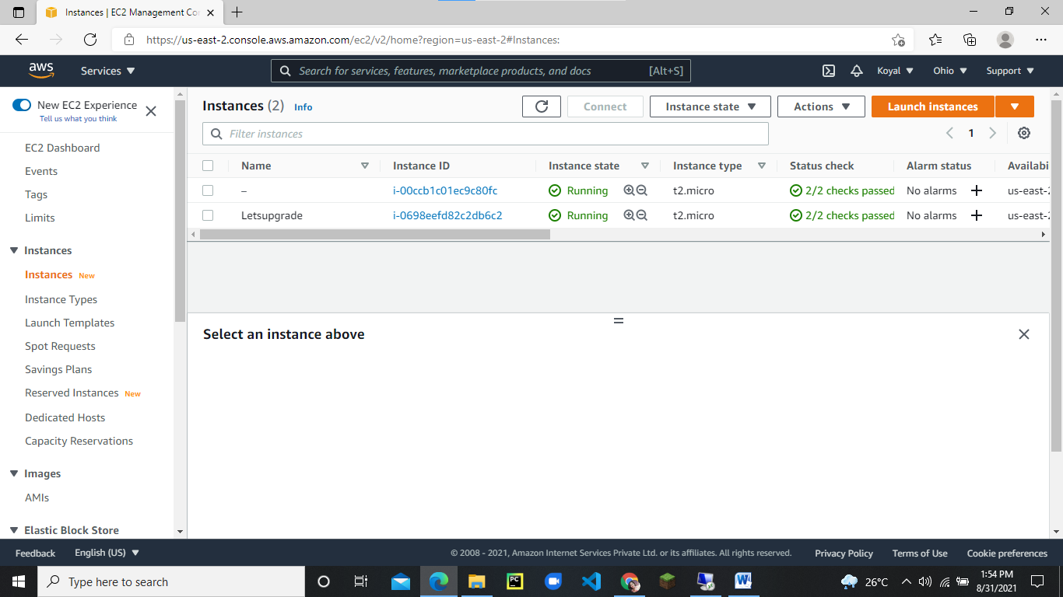

Click on connect:

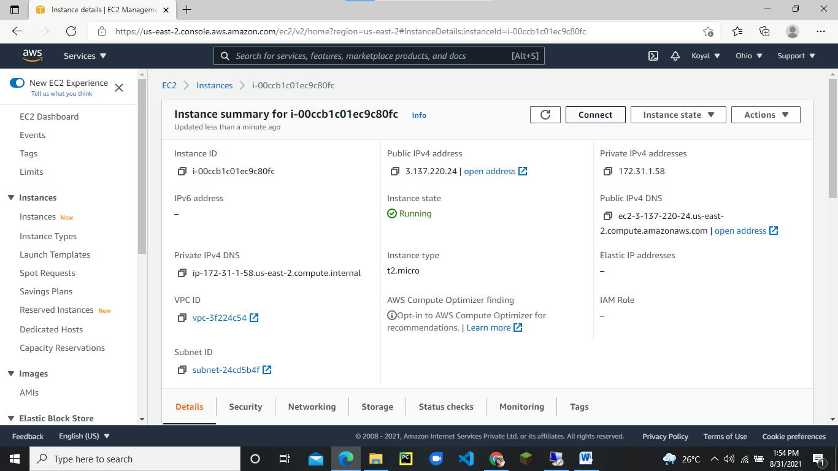

Go to RDP client:

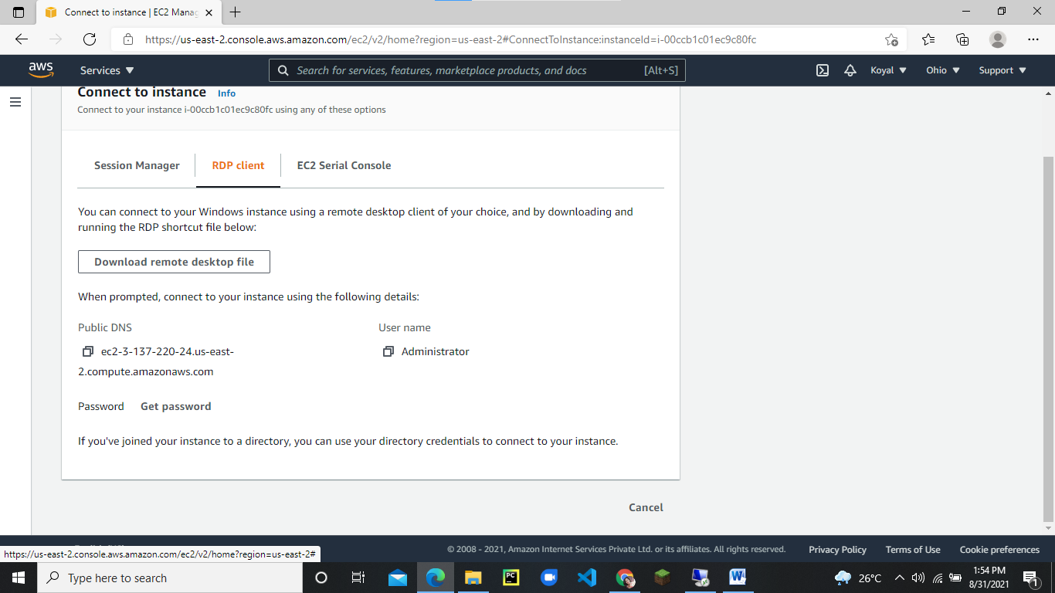

Download remote desktop file:

Then click on Get Password:

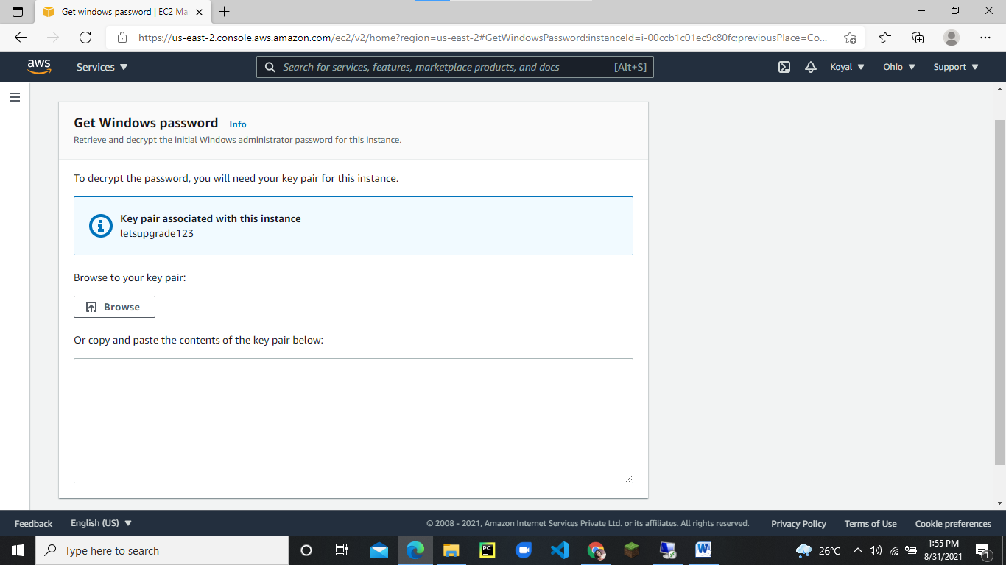

Then browse the key pair:

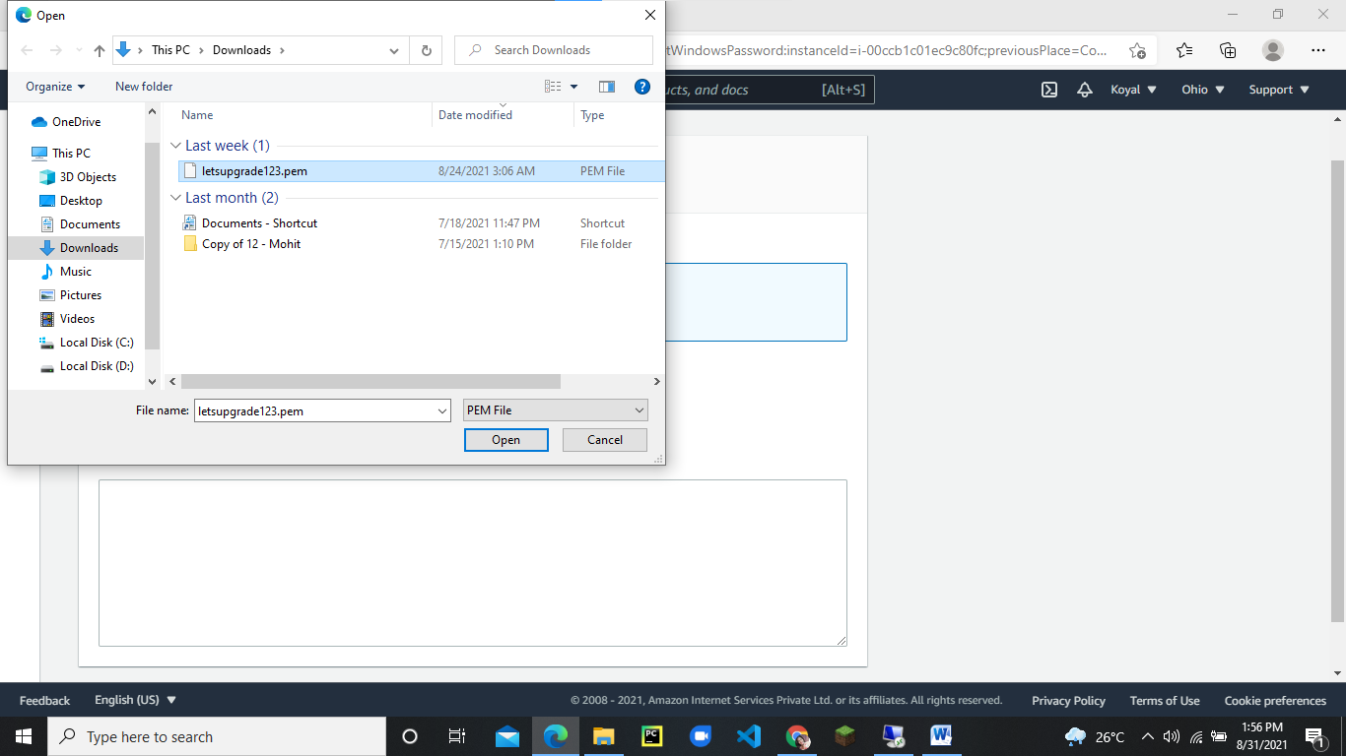

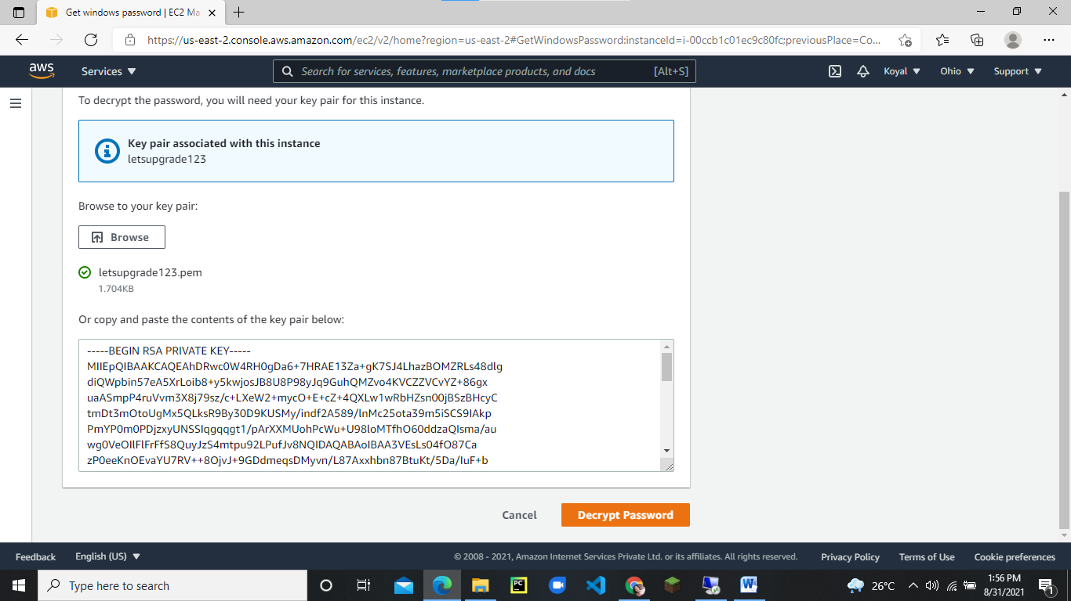

then decrypt password

then copy the password:

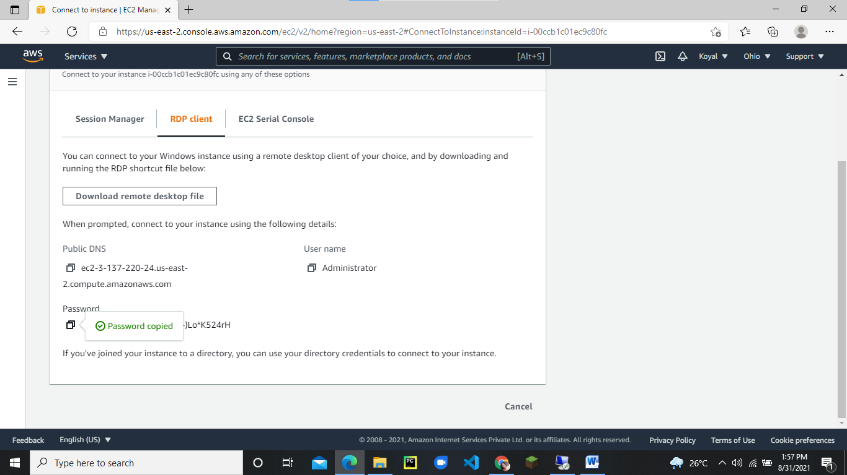

Then open the downloaded remote desktop file

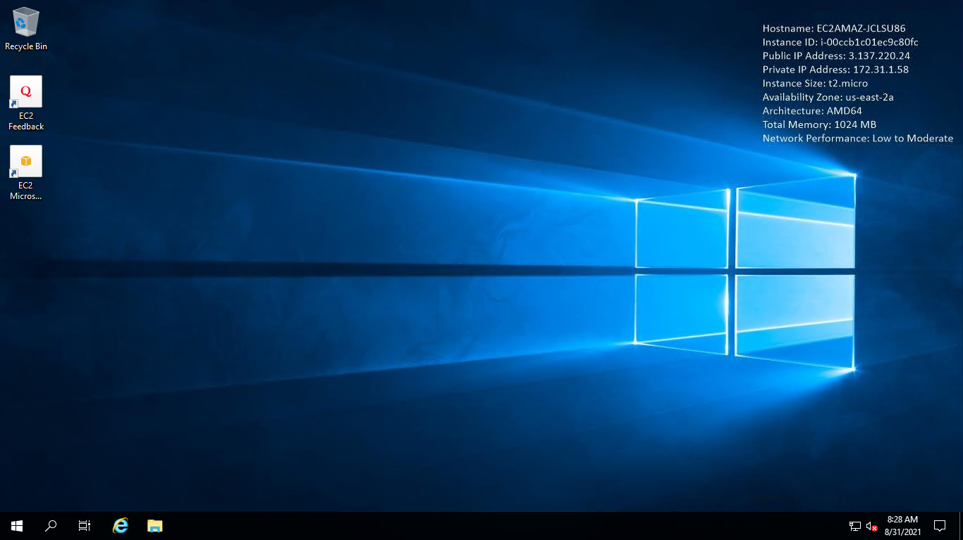

Open powershell in RDP:

Install-WindowsFeature -name Web-Server -IncludeManagementTools

Type this and click on enter:

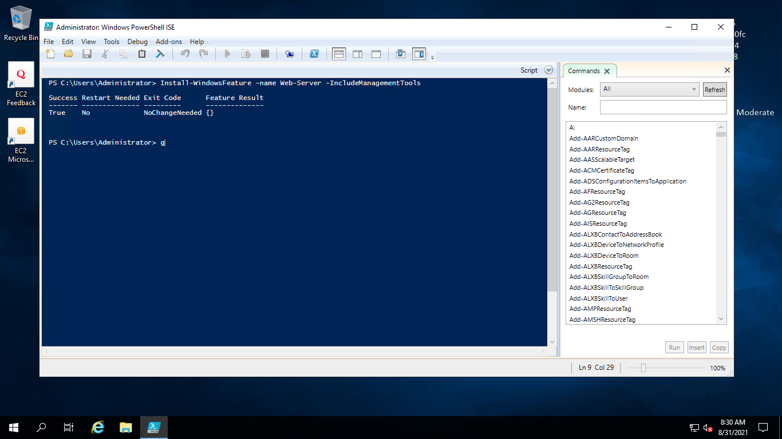

Then now go to Instances:

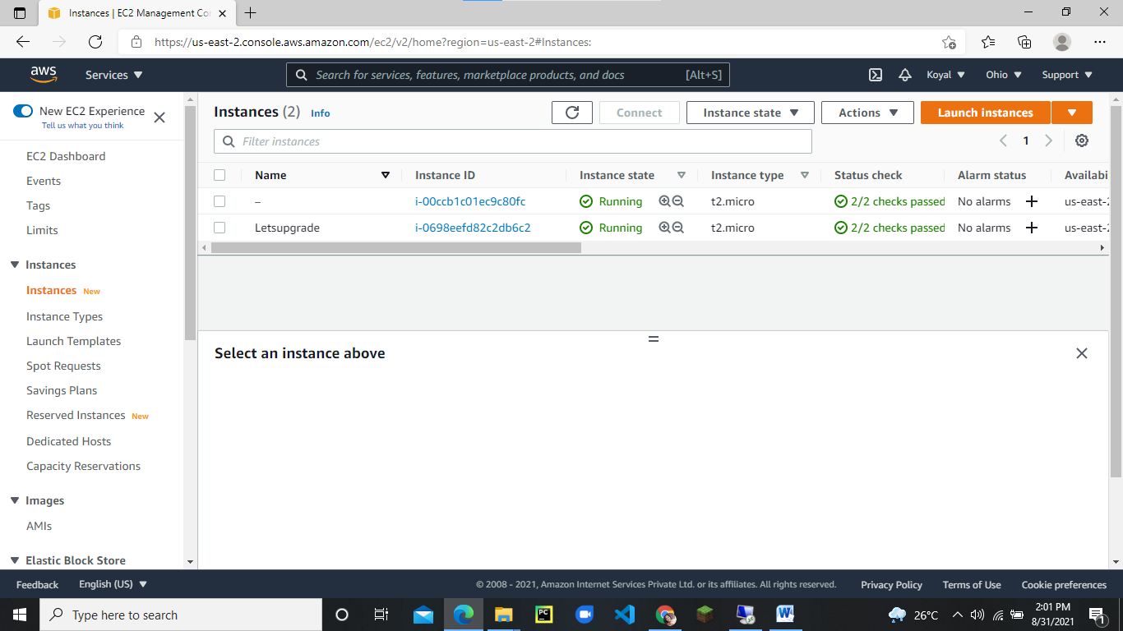

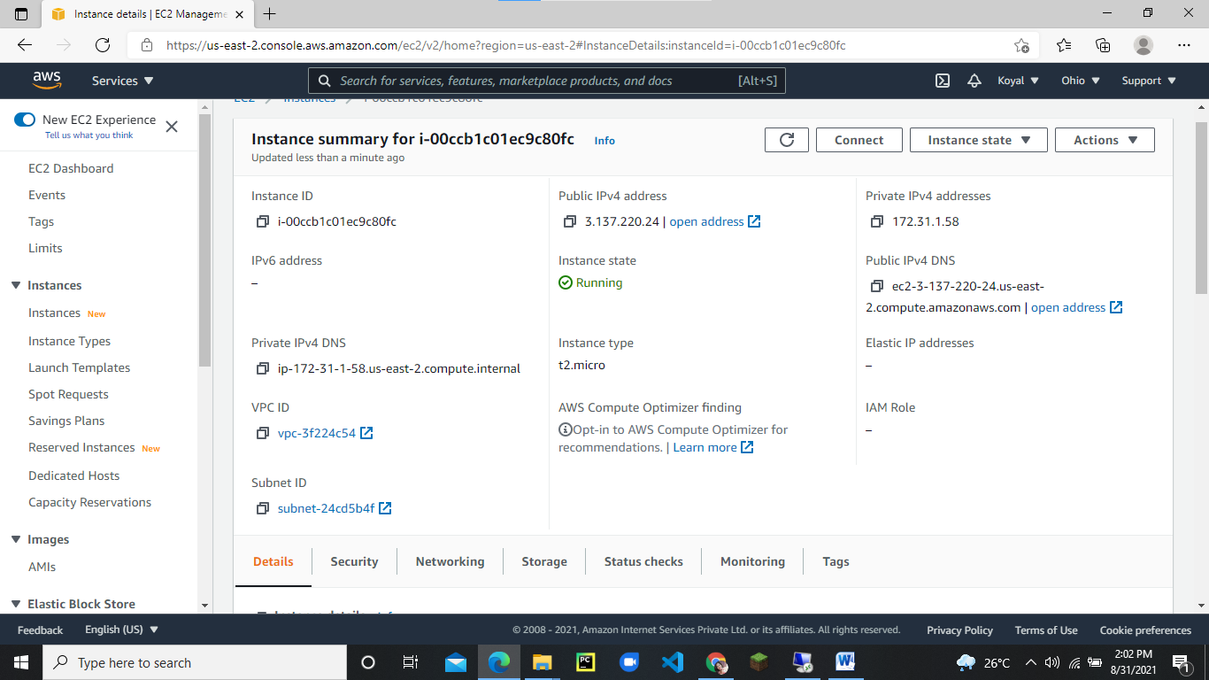

Click on IPv4 address:

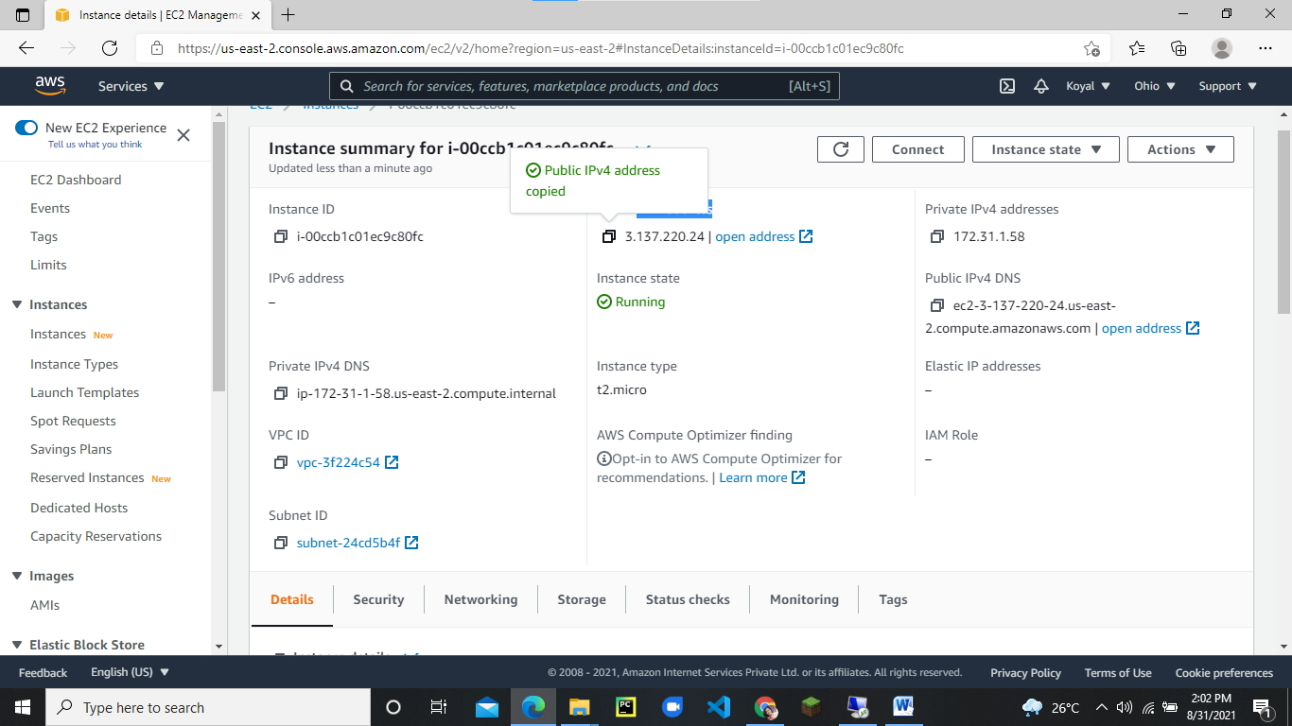

Now paste that IP address on new tab :

Now have a look we have created Windows IIS server:

